Importance of Relationship Marketing Management in a Competitive Environment - An Analysis of Vodafone in

UK

Acknowledgement

This research study is an outcome of my sheer dedication but the overall process was assisted by a number of people and groups who devotedly guided me in successfully accomplishing my objectives. I express my deepest gratitude to all who have been pillars of support in this entire course of action.
I express my thankfulness towards my research guide, PLEASE SPECIFY NAME, DESIGNATION AND ORGANZIATION OF GUIDE who has been an excellent guide throughout and provided me with a cordial environment for completion of the research study. I also communicate my regards to all the teaching and non-teaching members and the institute’s library for being a constant support and source of knowledge. Special thanks to the institute and the university for designing such a program and being a source of continuous support throughout the programme. I am also indebted to my friends, colleagues, family members and my respondents for their kind help. Lastly, I would like to express my gratitude towards my parents and GOD for encouraging me to successfully complete the research against all odds.

Thank You All

Abstract
The research shows that relationship marketing plays a positive role in assisting a company to gain competitive edge over others in industries subjected to higher levels of competition. The primary aim of this study is to determine the significance of approaches undertaken in lieu of relationship marketing in a highly competitive environment especially within the telecom sector in the UK. In order to do so the chosen company is Vodafone from the UK. The primary focus of this study is on customer relationships and marketing approaches adopted by Vodafone company to lure these customers.
The study has been developed on both primary and secondary data. Primary data is collected from consumers of Vodafone through a survey using a close-ended structured questionnaire. The data has been analysed using statistical tools like correlation, regression and ANOVA with the help of SPSS.
The findings reveal that customers are satisfied with the relationship marketing approaches of Vodafone. This is evident from their acceptance of services offered by the company and higher levels of commitment and loyalty towards the company. However, to sustain competitive edge within the industry and have sustained relationships with the customers it is recommended that Vodafone should invest in employee training and development, design promotional offers for consumers, provide quality services to its customers and become more socially responsible.

Table of Contents
Acknowledgement 2
Abstract 3
List of Tables 6
List of Figures 7
List of Abbreviations 8
Chapter 1: Introduction 9
1.1 Background of the Study 9
1.1.1 Telecom Industry of the UK 9
1.1.2 Vodafone UK Company Profile 10
1.2 Problem Statement 10
1.3 Research Purpose 11
1.4 Research Justification 11
1.5 Research Questions 12
1.6 Research Objectives 12
1.7 Methodology 13
1.8 Dissertation Overview 13
Chapter 2: Literature Review 15
2.1 Chapter Introduction 15
2.2 Evolution and Concept of Relationship Marketing 15
2.3 Theory of Relationship Marketing 18
2.4 Importance of Relationship Marketing 20
2.4 Pitfalls of relationship marketing 23
2.5 Relationship marketing in Telecom Industry 24
2.6 Relationship Marketing Strategies 27
2.7 Chapter Conclusion 28
Chapter 3: Research Methodology 29
3.1 Chapter Introduction 29
3.2 Research Design 29
3.3 Context of the Research 30
3.4 Sample and Sampling Procedures 31
3.3.1 Population 31
3.3.2 Sample Size 31
3.5 Data Collection 31
3.5.1 Sources and Methods 31
3.5.3 Instrument 32
3.6 Measures 32
3.7 Pre-Tests 32
3.8 Procedures for Data Collection 33
3.9 Data Preparation 33
3.10 Chapter Conclusion 33
Chapter 4 Data Analysis and Interpretation 34
4.1 Chapter Introduction 34
4.2 Analysis of Quantitative Data 34
4.2.1 Reliability Test 34
4.2.2 Demographic Analysis 35
4.2.3 Inferential Analysis 41
4.2.4 Consumer Satisfaction Levels and Suggestions 47
4.3 Data Interpretations 51
4.4 Chapter Conclusion 53
Chapter 5 Findings, Conclusion and Recommendations 54
5.1 Chapter Introduction 54
5.2 Findings and Conclusion 54
5.3 Recommendations 56
5.4 Future Scope of Research 57
References 58
Annexure 62
Annexure 1: Questionnaire Cover Letter 62
Annexure 2: Quantitative Questionnaire for Consumers 63
Annexure 3: Reflective Statement 66

List of Tables
Table 1 Reliability Test Results 35
Table 2 Age Analysis 35
Table 3 Gender Analysis 36
Table 4 Occupation Analysis 37
Table 5 Years of Association 39
Table 6 Type of Vodafone Connection Prevalent in the UK 40
Table 7 Regression and ANOVA Analysis for Customer Acceptance of Vodafone Services 42
Table 8 Regression and ANOVA Analysis for Customer Commitment and Loyalty towards Vodafone Services 45
Table 9 Customer Satisfaction with Services offered by Vodafone 47
Table 10 Customer Satisfaction with Prices charged by Vodafone 48
Table 11 Customer Recommendations to Improve Relationship Marketing by Vodafone 50

List of Figures

Figure 1 The UK's Telecoms Industry Revenues 9
Figure 2 Development in marketing 16
Figure 3Influences on Relationship Marketing 18
Figure 4 The Differences between Transactional marketing and Relationship marketing 28
Figure 5 Age Analysis of Respondents 36
Figure 6 Gender Analysis 37
Figure 7 Occupation Analysis 38
Figure 8 Years of Association 39
Figure 9 Type of Vodafone Connection Prevalent in the UK 41
Figure 10 Customer Satisfaction with Services offered by Vodafone 48
Figure 11 Customer Satisfaction with Prices charged by Vodafone 49
Figure 12 Customer Recommendations to Improve Relationship Marketing by Vodafone 51

List of Abbreviations

4Ps – Product, price, place, promotion
CAGR – Compound Annual Growth Rate
CRM – Customer Relationship Management
IT – Information Technology
MNO - Mobile Network Operators
Ms Excel – Microsoft Excel
MTN - Mobile Telephone Network
Ofcom - The Office of Communications
PwC – PriceWaterHouse Coopers
UK – United Kingdom
SPSS - Statistical Package for the Social Sciences

Chapter 1: Introduction

1.1 Background of the Study

1.1.1 Telecom Industry of the UK
Within the whole Europe it is the United Kingdom (UK) which is considered as one amongst the largest market for the telecommunications industry. The industry has been exposed to intense competition especially in services related to mobile segment and broadband segment (Lancaster, 2017). The revenue earned by the overall sector is depicted in figure below:
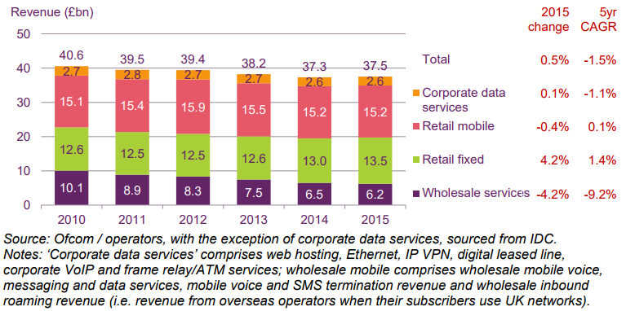
Figure 1 The UK's Telecoms Industry Revenues
Source: (Ofcom, 2016)
Though in 2015 there has been a decline in CAGR (a measurement of growth rate over differing time scales) of the industry but it has been anticipated that during the period ranging between 2016 to 2020 the industry would experience a CAGR of 4% (Euromonitor International, 2016). With higher levels of infiltration of both mobile phones and broadband with the widespread usage of smartphones a surge has also been observed in the segment of digital television (Lancaster, 2017; Euromonitor International, 2016). The most significant players within the indsutry are BT Group Plc, EE Ltd, Telefonica UK Ltd who have gained leadership position through consolidation and aim to continue with this approach.

1.1.2 Vodafone UK Company Profile
The origin of Vodafone can be traced back to 1983 when the Racal Electronics Group won a bid and got UK Cellular licence to operate as a private service provider. The formal name ‘Vodafone’ was given in the year 1984. Since then the company has been progressing and operating efficiently which is evident from its widespread presence in the global markets. Today, the company is operational in around 26 nations serving approximately 444 million customers depicting its widespread coverage. In the UK alone, the company has around 19.5 million customers. As a matter of fact, UK is one of the largest sources of revenue for the company and thus its leadership within this market is very crucial. With its headquarters in London, the UK the company offers a wide array of services to its customers. These services range from telephony (mobile and fixed), internet and broadband and other related services (GlobalData, 2015).
The company has been dedicatedly working for the development of its IT structure in order to provide for quality services to its customers. An example of the same is an outlay of 42 billion Euros that has started in the year 2012 for upgrading, standardizing and universalization of its IT mechanisms (Vodafone Plc, 2015).

1.2 Problem Statement
With Brexit, significant changes have been taking place within the telecommunication industry. The primary reasons behind these changes are issues in sourcing talent and channelizing its flow along with depreciating value of pound (PwC, 2016). Further telecommunication industry being a technology oriented it needs to undertake innovation at a faster pace which not only require investments but also innovative expertise also. So, availing these would be very challenging. Amidst all these challenges one thing that needs to be focused upon are the customers as they are the centre of any organisation and thus responsible for its success.
In such a scenario where the industry is experiencing dynamic changes, management and retention of customers for telecommunication companies is very challenging. An example of this a fine of 4.6 million pounds imposed on Vodafone by Ofcom (Chapman, 2016). This fine was levied for the company’s inability to efficiently deal with complaints filed by the consumer as well as for provision of substandard services to its customers availing services under the category of pay-as-you-go.
Such issues have resulted is a negative branding for the company which might create dire consequences for Vodafone under circumstances where corrective actions are not taken in due time. Vodafone’s failure to provide quality services in the long run might hamper its relationships with all its stakeholders, with customers being the primary ones. Unmanaged relationships would then trigger customers switching over to competitors who would provide for quality services at better deals making survival of Vodafone questionable (Bejou & Palmer, 2012). Thus, relationship marketing with respect to customers has been chosen as the main focus of this study. This will help in comprehending the customer perspective and thus gain comprehensive learning about relationship marketing.

1.3 Research Purpose
The primary aim of this study is to determine the significance of approaches undertaken in lieu of relationship marketing in a highly competitive environment especially within the telecom sector in the UK. In order to do so the chosen company is Vodafone from the UK. The primary focus of this study will be on customer relationships and marketing approaches adopted by Vodafone company to lure these customers.

1.4 Research Justification
Relationship marketing is very crucial for companies operating within dynamic and competitive environment. As customers are the most significant aspect for any industry including telecommunications it is important to focus on this aspect of marketing. With customers losing hope in Vodafone for low quality inappropriate services such study will assist marketers to take corrective actions. Along with marketers of Vodafone other companies can also use information provided and thus continue to experiment in designing products and services to delight customers. Students will also benefit from this study as it will provide them in-depth understanding of the industry as well as relationship marketing. Finally, researchers and academicians intending to take up research in this field might use this study for gaining conceptual knowledge.

1.5 Research Questions
- How effective is Vodafone’s relationship marketing approach in satisfying customers by meeting their requirements?
- How can a company like Vodafone derive higher customer loyalty and customer commitment from relationship marketing in a competitive business environment?

1.6 Research Objectives
The objectives are:
- To review existing literature on relationship marketing with particular emphasis on telecommunication sector in order to identify key research challenges
- To determine perceptions of customer care and relationship marketing approaches adopted within the telecommunication industry by Vodafone
- To determine the role of relationship marketing in creating customer commitment and loyalty towards Vodafone
- To identify ways in which effective relationship marketing practices undertaken by Vodafone might be enhanced
- To reflect on the implications of the analysis for research on relationship marketing in telecommunications industry

1.7 Methodology
This study is developed on the basis of primary and secondary data that has been collected to meet research objectives and answer research questions related to relationship marketing of Vodafone. Quantitative data has been gathered from customers with the help of questionnaire survey. In order to solve the problems a deductive approach has been deployed. Data analysis has been done using statistical tools available in SPSS.

1.8 Dissertation Overview
The whole research study has been segmented into 5 chapters whose briefing has been provided below:
- Introduction: This chapter which marks the beginning of the study will develop a background to support the overall study. This chapter also highlights the aims and objectives which the study offers to achieve.
- Literature Review: This is the second chapter and it irradiates and critically examines the existing literature on relationship marketing, thereby developing a powerful theoretical groundwork of this study.
- Research methodology: The research methodology is the third chapter which outlines the research process espoused for this study. The research process for this study is based upon quantitative approach which has been clearly explained in the chapter.
- Data Analysis: This significant chapter provides an in-depth analysis of the primary data which has been collected and analysed using statistical tools.
- Finding, Conclusion and Recommendation: This final chapter points out the most significant findings from the study and analysis of data thereby assisting in developing a concluding remark. The chapter also points out the varied recommendations that can be adopted by Vodafone to meet issues identified from the study.

Chapter 2: Literature Review

2.1 Chapter Introduction
The second chapter of this research that is Literature Review is explicated to obtain a comprehensive insight to the topic. The chapter is developed by considering and deducing wide-ranging data recovered from secondary sources. The primary objective of this chapter is to develop a conceptual framework for the topic under study that is importance of relationship marketing management in a competitive environment for Vodafone in UK.
At the outset of the chapter Concepts and Evolution of Relationship Marketing is discussed followed by importance of relationship marketing in the competitive business environment. Further the chapter identifies the pitfalls of relationship marketing. Progressing further the chapter explores relationship marketing in the telecom industry and reviews various models of relationship marketing. Lastly, the chapter is wrapped up by highlighting and emphasising the main points understood from this study.

2.2 Evolution and Concept of Relationship Marketing
The concept of relationship marketing got attention in the last decade of the 20th century. It became a trend in the field of marketing and the scope of relationship marketing was extensive enough to cover the complete range of sub-discipline of marketing such as service marketing, direct marketing, marketing research, marketing communication, and customer behaviour to cite a few. There was a rapid development in the field of marketing which gave rise to relationship marketing in 1990s.
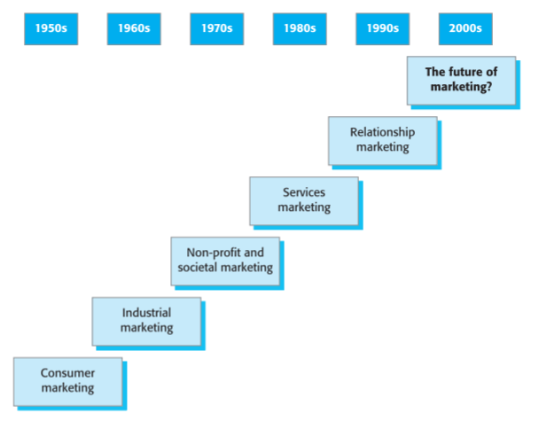
Figure 2 Development in marketing
Source: (Egan, 2011)
Hollensen & Opresnik (2010) were of the opinion that relationship oriented marketing practices started from the pre-industrial era. Nevertheless, the growth of publicising as an area of learning and practice is experiencing a re-conceptualization in its focus from dealings to relations. This is evident from a series of studies undertaken in the area of relationship marketing. The stress on associations in contrast with the deal based trades is expected to redefine the area of marketing. Without a doubt, the advent of a relationship marketing is on the horizon given the mounting interest of marketing specialists in the interpersonal pattern.
Though there is no standard definition of relationship marketing, many scholars attempted to present their views about the notion of relationship marketing. Cravens (1995) defined relationship marketing in Agariya & Singh (2011, p.208) as “It is the strategy for business organisation to enter into long term association with customers and to counter the effects of increased customer demands and intensifying global competition.”
Benouakrim & Kandoussi (2013, p. 148) defined relationship marketing as, “relationship marketing is a strategic process aiming to establish, develop, maintain and strengthen the network of relationships with various stakeholders on the basis of strong economic and social standards and the achievement of common objectives.” It was observed that in relationship marketing, the notion of long term is very crucial. However, there are other certain variables which are indispensable in maintenance and development of relationship such as commitment, cooperation, relationship quality and trust.
Paliwal & Indu (2013) associated relationship marketing with the happiness of the customer. Kotler and Keller (2009) defined customer relationship marketing in Paliwal & Indu (2013, p.409) as “customer relationship marketing is the process of attracting, building and retaining customers.” Customers feel happy and contended with good relation is maintained with them by the marketers. And thus, many business organisations use relationship marketing as an instrument with a motive to maintain clienteles for longer period of time.

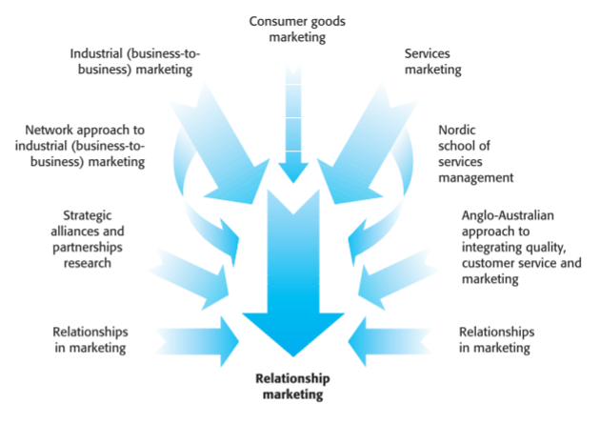
Figure 3Influences on Relationship Marketing
Source: (Egan, 2011)
The notion of relationship marketing goes beyond transactional give-and-take as it is established on the objective of business to provide enhanced value by giving emphasis to purchasers' viewpoints as the central point of connection building actions. It was witnessed that relationship marketing would function efficiently when consumers are greatly entangled in the merchandise or service. Moreover, there is a component of personalization in relationship marketing (Egan, 2011). It was also argued that in relationship marketing, relational exchanges are done by the customers with the organisation only when they contemplate that the paybacks resulting from such interpersonal exchanges overdo the costs. By constructing and preserving robust and profile association with clienteles, establishments also acquire usable info source for operative publicising intelligence in order to articulate marketing approaches for their target customers. In addition to this, relationship marketing also assists organizations to increase their market share and productivity and concurrently lessen their cost of dealing with the consumers (Hollensen & Opresnik, 2010). However, Palmatier (2008) and Hollensen & Opresnik (2010) notified that the costs involved in relationship marketing is relatively higher then mass marketing which makes it difficult for marketers to opt for this option. Another major issue with relationship marketing is unavailability of expert employees which prohibits companies from gaining desired benefits through such approaches. For preparing a pool of talented employees companies need to make huge investments in form of training and development who might not be loyal to the company thus further adding to organisational costs.

2.3 Theory of Relationship Marketing
One of the most prominent theories of relationship marketing is the commitment-trust theory. This theory states that commitment and trust are the two fundamental factors of relationship marketing and they must exist for the successful relationship between the buyer and the seller. Moreover, relationship marketing involves creating ties with clienteles by meeting their requirements and honouring promises. Organisations that abide by the principles of relationship marketing establish long-lasting connections with their consumers. This result in the building of mutual trust among them and customer loyalty helps the organisations in achieving their goals on one hand and commitments of the organisation helps the customer in satisfying their needs.
Morgan and Hunt (1994) in Palmatier (2008) explicated that in The Commitment-Trust Theory of Relationship Marketing, association promise and belief is much more important than power. This though is fundamental to construction of positive relationship marketing. Moreover, they defined relationship commitment as a persistent aspiration to preserve a treasured relationship and trust as the assurance in an exchange companion’s consistency and honesty on the basis of their research done in the marriage, social exchange theory and organisational behaviour. They further advocated that these are the fundamental elements that elucidate an association's effect on performance. Thus, relationship associates who are dedicated spend additional energy and effort to preserve and reinforce interpersonal links, which certainly impacts collaboration, monetary performance, and other constructive upshots.
In addition, faith has a straight influence on relationship consequences. It also influences obligation of a person towards the company or another person. Largely, Morgan and Hunt’s (1994) model of relationship management decreases the scope from Dwyer, Schurr, and Oh’s (1987) agenda in two crucial manners: it constricts the interpersonal paradigms of interest to faith and obligation and overlooks any vibrant relationship consequences (Palmatier, 2008). Nevertheless, theoretic disparities appeared in the structure during the course of pragmatic analysis via meta-analysis of more than 111 autonomous samples enfolding 38,000 relational and inter structural associations. Though this current research blend delivers robust empirical backing for the acute role of obligation and faith, it also unearths two main flaws. Firstly, relationship outlay has a constructive unswerving influence on objective enactment. This result recommends that any theory must embrace additional performance-enhancing intermediaries if it wishes to seize the constructive monetary influence of relationship marketing completely. Secondly, in contrast to conformist wisdom, association quality, an amalgamated theory that seize manifold facets or magnitudes of a relationship, has a sturdier influence on objective enactment than any solo element.

2.4 Importance of Relationship Marketing
McMullan & Gilmore (2008) propounded that superior information and understanding of consumer faithfulness may permit businesses to streamline their management approaches to encounter the diverse requirements of its clienteles in a more operative fashion and hence, occasioning in a more cost-effective business. Consequently, customer relationship management has been implemented by the leading hotels in? this competitive environment for offering their consumers an exceptional and satiating experience by precisely recognizing their numerous requirements.
Relationship marketing helps in gaining loyalty of the customers. It has been witnessed by whom? that positive word of mouth and customer loyalty are the two main consequences of effectual relationship marketing. Moreover, customers are also benefitted by the exclusive benefits derived from relationship marketing as per Palmatier, et al. (2009). With the help of relationship marketing, competition of the company from the other counterparts offering same products is reduced and the company enjoys the loyalty of the customers. Loyal customers are more expected to expend additionally and frequently make approving endorsements to other probable consumers. By investing in relationship management, firms are capable enhancing their performance far beyond the acknowledged starring role of belief and assurance. It was proposed that appreciation, the emotional gratitude for paybacks received, supplemented by a wish to respond is a significant construct for understanding the effectiveness of relationship management. Investment in relationship management helps in generating gratitude among customers resulting in their reciprocal behaviour and augmented performance of the seller.

Lo & Stalcup (2010) specified that with an intent to integrate various aspects prevailing in the company, relationship management has been employed so that they can maintain long and profitable relationship with their customers.
Egan (2011) advocated that a biggest change in marketing management has been brought by relationship management. Relationship management lay emphasis on the retention of the customers thereby assisting the organisation in maintaining the profitability.
Talking about relationship marketing in the banking sector, Taleghani, et al. (2011) explicated that it is imperative for the banks to differentiate them from the competitors. In this regard, relationship marketing has been promoted as an outstanding approach for banks to institute an exceptional long-term association with their clienteles. Moreover, this concept is gaining popularity as it benefits both the enterprise and the customers by building relationship between them. By building relationship, organisations are also capable of gaining competitive advantage. In relationship marketing prominence is being given in maintaining long term association, so businesses consider their dealers and clienteles as companions, where the objective is to generate joint value.
Lacey et al. (2007) pointed out that relationship marketing is very crucial in the contemporary business environment to keep the business alive. However, it was also argued that it is not commendable to preserve close association with all clienteles. This is because few of them may not be attuned with goal of the business due to the variations in their requirements and behaviours. Thus, the businesses must reconsider their outlay on consumers and end unproductive associations. They also elucidated that when a consumer has gratification of merchandise, advertising, price and placement, it is possible that there is contentment of association between consumer and vendor. They also emphasized on customer retention explicating that it is the outcome of relationship marketing and that customer retention helps in increasing profitability and saving cost which the prime goal of all the firms.
The views of the above scholars were also substantiated by Bazini, et al. (2012). They highlighted the importance of customer loyalty gained by way of relationship marketing. In addition to this, it was pointed out that in the recent past, executives have begun to understand the significance of holding active consumers with businesses as a strategic constituent ensuring their endurance in the marketplace.
While all the above scholars talked about customer satisfaction, customer loyalty and customer retention as the outcome of relationship marketing, Rizan, et al. (2014) accentuated the prominence of trust developed through relationship marketing. They asserted that once the association is built between the buyer and the seller, the buyer builds a confidence in the seller. This ultimately helps in gaining loyal customers.
To summarize the above discussion, the main advantages of relationship marketing can be listed as follows:
- Increase in customer loyalty
- Increase in sales with minimal investment
- Helps in creating positive one to one marketing
- Enhances personal connection
- Helps in attaining trust of customers

2.4 Pitfalls of relationship marketing
Relationship marketing is considered to be the most popular strategy of marketing. Nevertheless, there are shortcomings a business should contemplate before selecting for relationship marketing approach as denoted by Palmatier (2008). It can be problematic for an organisation to compute the impact on sales by specific marketing/client service ingenuities when they employ numerous relationship marketing approaches. Moreover, this is a holistic approach to marketing in which there may be no noticeable association amid cause and effect. Further, companies need to change their mind-set from traditional approach of marketing to contemporary approach. Therefor many companies find it difficult to implement relationship marketing in their organisation (Palmatier, 2008). This approach can be disadvantageous for small firms as expertise, money and time are essential for setting up of social communication channel and marketing endeavours. The budget of the company also increases as they need dedicated staff that can efficiently manage the accounts on social media.
As per Akers (2017) maintaining relations with the customers through direct marketing can be very expensive to the organisation as compared to the other forms of marketing. This is because it is more time consuming and entails the high degree of personalisation. Organisations are compelled to communicate with its customers on one to one basis which requires more skilled staff. In addition to this, one of the major pitfalls of relationship marketing is maintaining sensitive data which invites security issues to the organisation. Business is put at risk for accountabilities when the specific information of the customers is frequently gathered on servers and in electronic databases. In several cases, customers show reluctance in sharing their information which makes the process of relationship management intricate. Furthermore, it has been witnessed that no strategy is flawless and so do relationship marketing. According to a publication on Channel Reply (2015) this stragey also does not support all the business models and turn out to be very expensive for most of the organisations.
Many times, companies fail to concentrate on the customers who are certainly interested in their goods and services as avowed by King (2017). Companies largely make mistake by focussing on those customers who are already buying their merchandise and services. Apart from this, companies also sometimes over advertise their products making customers irritated. Daily mails and text messages result in overwhelming the customers and this can lead to the reduction of sales of the company.
To summarize the above discussion, the main pitfalls of relationship marketing can be listed as follows:
- More attention is paid on existing customers
- Relationship marketing campaign can be ruined due to negative information
- It is time consuming marketing strategy
- Change in culture is required at times
- Customers becomes demanding
- New customers are often neglected

2.5 Relationship marketing in Telecom Industry
The impact of relationship marketing on the satisfaction of customers in telecommunication industry of Nigeria was investigated by Ojo (2010). They carried out a quantitative study involving 230 respondents. The study revealed that by managing proper relations with customers and providing quality service to them resulted in high customer satisfaction. This further led to enhanced customer loyalty and retention.
A year later, Koi-Akrofi, et al. (2013) assessed the impact of relationship marketing strategies on client faithfulness in the Ghanaian mobile industry wherein deregulation has resulted in extreme competition and struggle for gaining market share. Brand image, price perception, service quality and value offered were the four relationship marketing tactics employed in the study to examine their influence on customer faithfulness in the Ghanaian cell phone industry. A quantitative study was carried out entailing 40 respondents of Ghana. The results exhibited that there exists a constructive substantial association amid each of the four relationship marketing strategies and customer faithfulness. The study proved to be helpful for the marketers in the telecommunication industry in making the knowledgeable decision about the relationship marketing blend pertinent to the existing client’s requirement that creates rise in profits and revenue.
Koi-Akrofi, et al. (2013) also opined the prominence of gaining customer loyalty in the hyper-competitive environment stating that it is indispensable for a long term and lucrative association with their clients. They explicated that relationship marketing is an integral part of the service industry. Though many tactics are used by the marketers to retain their customers, yet they switch to the other brands if the approach adopted by the marketers turn out to be ineffective. In this regard, Raza & Rehman (2012) investigated the association of these advertising tactics on faith and gratification of a customer, which eventually upsurges client faithfulness in telecom sector of Pakistan. A quantitative study was carried out entailing 210 mobile users of four companies of Pakistan. The study revealed that gratification and faith may upturn customer faithfulness.
Abdullah, et al. (2014) propagated that in the recent times, incessant expansion of reciprocal long-term relationship policy with clienteles has been one of the highest primacies for most businesses. The study was to observe the effect of relationship marketing strategies and relationship quality on client faithfulness with the help of Commitment-Trust Relationship Marketing Theory and Pull-Push-Mooring (PPM) Migration model in Malaysian mobile telecom industry.
The Nigerian perspective of the telecom industry in the context of relationship marketing was also presented by Ibok & Sampson (2014). They examined the numerous relationship marketing ideas by means of the concepts of faith, mutuality, compassion and attachment. The key drive was to untie the relative effect of these features on the efficiency of relationship marketing within the framework of the Nigerian telecommunication industry. They acknowledged that these features are imperious for operative relationship marketing.
In the same year, Tauni, et al. (2014) carried out a study with an intent of investigating the association between client relationship management and client retention in telecommunication industry of Pakistan. They affirmed that modern marketing pattern depends on mounting long-term relations with the clienteles and offering them value and gratification to preserve them. A quantitative study was undertaken in Pakistan entailing 60 customers. It was discovered that preserving sustainable relationships with the client can stimulate to preserve clienteles and can be favourable for the businesses. Moreover, CRM and client preservation are considerably linked.
Yet another Nigerian perspective was presented by Emmanuel, et al. (2016). They examined the impact of relationship marketing on the loyalty of the customers in the telecom industry of Nigeria. The study instituted that Mobile Telephone Network (MTN), Nigeria were not able to manage with offering enhanced telecom services subsequent the reported cases of persistent meagre services and impolite behaviour of subscribers (clienteles) that could not match the kind of well-organized network and sincere client service associations required to generate and preserve faithful clienteles in telecom industry in Nigeria.
In the above section, the brief overview was presented about the relationship marketing strategies adopted by the marketers in the telecom industry of various countries. From the literature review it is evident that relationship marketing is critical to any industry. However, no significant study with regards to the UK has been found which creates a gap in available literature. In the subsequent section, the theory of relationship marketing has been discussed.

2.6 Relationship Marketing Strategies
Cheng & Lee (2011) explicated relationship marketing to a most powerful armament that assists firms to endure in the contemporary business environment. Moreover, the relationship marketing strategies adopted by the firms helps them in enhancing business performance as identified by Adjei, et al. (2009). It was indicated that a superior vending channel owns a capacity to offer its clienteles with collaborative communications and compassionate sales environs. They also pointed out that relationship marketing was primarily concerned with matching the needs of the customers and the service assurance so that the client faithfulness would rise. Moreover, the purpose of relationship marketing strategy is to generate commitment to the customer.
Baird and Parasnis (2011) in Moretti & Tuan (2013) described that relationship marketing strategy is intended to manage consumer association as a way to unearth the utmost value from clienteles over the lifespan of the association.
The views of Adjei, et al. (2009) was also affirmed by Šonková & Grabowska (2015) stating that the ultimate aim of the relationship marketing strategy is to establish sturdy long-term relationships. At the present time, it is assumed that it cannot be contracted only to associations between consumers and the business. Gummerson (1994) in Šonková & Grabowska (2015) pointed out that there are about 32 different kinds of association that need to be taken care of by the marketers. Further, Buttle (1996) in Šonková & Grabowska (2015) constricts them by averring the three distinct approaches to relationship marketing namely the customer marketing strategy, the trade marketing strategy, and the internal marketing strategy.
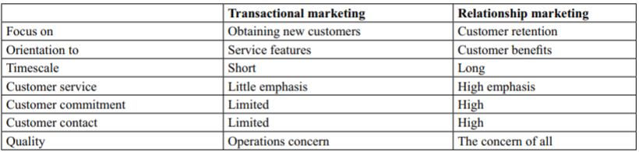
Figure 4 The Differences between Transactional marketing and Relationship marketing
Source: Šonková & Grabowska (2015)
In the same year, Alibhai (2015) propounded that CRM as a business strategy recognises, fosters, and upholds long-term profitable consumer associations. In order to compete in such competitive and collaborating business environment, venders are enforced to look beyond the old-fashioned 4Ps of publicising approach for attaining competitive advantage. Consequently, relationship management amongst other advertising strategies has become a substitute way for establishments to construct robust, enduring links with their clienteles.

2.7 Chapter Conclusion
Relationships and communications are an essential element of the human society and have inexorably supplemented the commercial practice since the commencement of business. Many businesses agreed that their long-term effectiveness is dependent on the satisfaction of its customers. In order to accomplish this, there’s a necessity to alter the approach the consumer is observed by executing two-sided communication with him, by captivating the customer’s conviction, by considering him as a companion that can add to value creation.
For the most of the businesses, the paybacks of relationship marketing are enormous. It is one of the most commercial marketing approaches accessible to a marketer. And possibly best of all, as it emphasises on retaining happy customers. Through this research marketers will be able to focus on specific strategies related to telecom industry and thus be successful in the long run. Further, comparative studies of differing industries and companies within the same industry to gain comprehensive insight to this strategic approach.

Chapter 3: Research Methodology

3.1 Chapter Introduction
The chapter brings to light the overall research process adopted for this study which encompasses aspects like research design, context, sampling, data collection and analysis, measures and stimuli, and data analysis. The study is based upon collection of primary data which has been discussed and justified in details in this chapter.

3.2 Research Design
A research design is basically determination of a plan that would be adopted for undertaking a research for finding solutions to research questions determined at the beginning of the study (Korrapati, 2016). The main motto of this study is to determine the perspectives of customers with regards to relationship marketing done by Vodafone in the markets of the UK thereby determine the significance of this strategy for the company. Thus, the study concentrates on consumer’s opinions who are customers of Vodafone. The research design is adopted is quantitative research design. Further an exploratory and descriptive research design was chosen for determination research motto.
Quantitative research design was chosen mainly as it assisted in quantification of factors thus facilitating transposition of information into numbers that can be systematically processed to derive conclusions (Creswell, 2014). An exploratory approach has been adopted as the researcher makes an attempt to explore the differing aspects related to relationship marketing especially from customer’s perspective and thus determine its significance for Vodafone in the UK (Lalaounis, 2017). Though the method does not support generalisation of findings but yet this approach was chosen as it assists in gaining in-depth understanding of the research topic under study. Further through exploratory approach an apposite interpretation of reality is possible. As this study involves analysis of current relationship marketing strategies as adopted by Vodafone in order to determine issues present through determination of customer satisfaction levels a descriptive approach has been espoused upon. This approach is adopted as there is no particular information with regards to the problem in hand which can be overcome in this study (Fox & Bayat, 2008).
From inductive and deductive approaches, a deductive approach was used for this research as this approach supports scientific examination of information (Saunders, et al., 2009). In this study also, information has been examined using statistical tools to reduce biasness and derive effective outcomes.

3.3 Context of the Research
The role of telecommunication industry in any economy is indispensable owing to its ability to provide for communication between people and businesses irrespective of geographic distance between them. With the emergence of wireless technology and internet the role and significance of telecommunications has multiplied considerably. Today it has become a necessity. Considering the growth of this industry a large number of companies have entered the same offering quality services are reasonable prices thereby resulting in intensification of competition. As the telecommunication industry is highly dynamic, management of customers for companies is very challenging and thus fascinating. Thus, telecommunication industry has been chosen to pursue a research study.
In the UK, Vodafone is serves as one of the four significant mobile network operators (MNO) with the other three being Three (3), EE and O2 (Statista, 2017). Irrespective of being such a significant operator Vodafone has been recently subjected to issues with customer services which has adversely affected its relationship with them This has been the central focus of the study for which Vodafone has been chosen.

3.4 Sample and Sampling Procedures

3.3.1 Population
The study mainly comprised of users of Vodafone services in the UK belonging to the age group of 18 years and above from London. This formulates the overall population for the research study.

3.3.2 Sample Size
A sample size of 100 consumers of Vodafone has been chosen using a snowball sampling which is a non-probability sampling approach. In this approach first, few consumers (known through personal references) were approached who were further motivated to provide information of other Vodafone users from their peer group (Bailey, 2008). This helped in assimilating a respondent database for information collection. In order to ensure that sample is normally distributed for a quantitative study it is important to have minimum 30 respondents (Brown & Coombe, 2015). Further, as the study is undertaken for academic purposes and subjected to limitations of resources conducting a survey of whole population was not possible, thus a sample of 100 was chosen.

3.5 Data Collection

3.5.1 Sources and Methods
For ensuring that an effective research is conducted which would add to existing literature a combination of primary and secondary research study was used in this study. Secondary information has been critically reviewed and presented in the previous chapter of literature review. This information assisted in developing a theoretical understanding of the aspects related to the research topic. Secondary sources comprised all published sources of information ranging from books, journals, newspapers, reports, websites and other similar sources. Information was collected through online sources and physical libraries (Saunders, et al., 2009).
Based on knowledge developed from secondary sources, primary information has been collected from customers of Vodafone in the UK through a questionnaire survey (Saunders, et al., 2009). This survey was conducted through emails thus an online approach was used.

3.5.3 Instrument
A survey method was adopted for collection of data from the consumers of Vodafone in the UK with regards to relationship marketing strategy. For this purpose, a structured questionnaire (annexure 1) with close-ended questions has been developed which acted as the instrument (Saris & Gallhofer, 2014). The questionnaire has been segmented into three categories. First category is about the demographic details of the participating respondents thus providing a fair idea of the respondent’s age, gender, occupation profile and basic relationship details with Vodafone. The second category is further divided into two major sections. The first section is designed to extract information related to customer acceptance of customer relationship marketing undertaken by Vodafone and the second section aims at deriving relationship between customer commitment, customer loyalty and relationship marketing by Vodafone. The third and final category seeks to understand the satisfaction level of consumers with relationship marketing strategy adopted by Vodafone and seek for recommendations from them.
This instrument was chosen to overcome the issue of bias and ensuring that a standardised approach is resorted to. The most significant reasons for choosing this instrument is to reduce biasness and provide ease of data analysis by considering the fact that the study has been subjected to constraint resources like time and money (Brace, 2008).

3.6 Measures

3.7 Pre-Tests
Pre-tests were conducted with 10 consumers of Vodafone in order to ensure that the questionnaire is appropriate, valid and reliable. The participants of pre-tests were representative sample respondents chosen or the main study. The questionnaire was revised based on their feedback and thus issues of missing information and questions seemed to be overlapping, questions or unclear were changed. This improvisation of the questionnaire assisted in conducting a quality research study. No major change was done in the questionnaire according to the feedback.

3.8 Procedures for Data Collection
For collection of data, first 20 consumers of Vodafone were approached from the known peer group of the researcher. These twenty were further requested to provide references of 5 Vodafone users. Thus, a database of 120 respondents was developed who were sent requests to be a part of survey. Once consent was received, the questionnaire was sent to them through emails. Out of 120 sent a total of 114 responses were received. Out of these 114 first 100 duly filled questionnaires were selected for further analysis. The respondents were provided with a time frame of 6 days from the date of receipt to complete the questionnaire and return.

3.9 Data Preparation
Once the data was collected it was prepared for analysis by filtering it. This data was recorded in an excel file in a systematic manner to ensure effective analysis can be undertaken. Once recorded in excel sheet, the data was transferred to SPSS so that analysis can be done. The analysis involved usage of statistical tools like frequency analysis and correlation and regression analysis to derive findings to meet research objectives.

3.10 Chapter Conclusion
The research method above provides a detailed outline of the process of research and thus shapes the foundation for the next chapter that is data analysis and interpretation.

Chapter 4 Data Analysis and Interpretation

4.1 Chapter Introduction
The chapter is developed in order to analyse the primary information that has been a collection for the first time through a survey of consumers of Vodafone in the UK. The chapter analyses and attempts to draws interpret quantitative data. The chapter is segmented into 2 major heads namely quantitative analysis and data interpretations.

4.2 Analysis of Quantitative Data
The questionnaire which assisted in the collection of primary data mainly had questions with 5- point Likert Scale (Bartolacci & Powell, 2012). The range of this scale was strongly agreed to strongly disagree thus gaining an insight into consumer perspectives. The information collected was recorded in Ms Excel sheet and then transferred to SPSS for further analysis. The demographic factors have been analysed using the frequency analysis whereas, for other segments on customer acceptance, customer commitment, customer loyalty and satisfaction with regards to relationship marketing of Vodafone has been analysed using correlation and regression. The information has been presented using tables and graphs along with its interpretations thus assisting in comprehensive understanding.

4.2.1 Reliability Test
To determine the internal consistency and reliability of the data collected from sample respondents a reliability test was undertaken using the Cronbach Alpha. Any score of this Alpha above 0.5 (within a range of 0 to 1.0) ensures that the data is consistent and further studies can be undertaken. In this study, the Alpha results are 0.947 as seen in the table below which indicates a higher level of consistency in data collected thereby making the data valid (Bradley, 2013). Thus, this data can be used for further analysis.
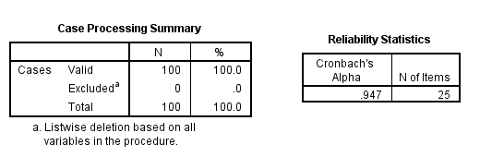
Table 1 Reliability Test Results

4.2.2 Demographic Analysis
Age Analysis
The respondents of this study belonged to different age groups thus ensuring that information has been collected from a well-distributed sample set.
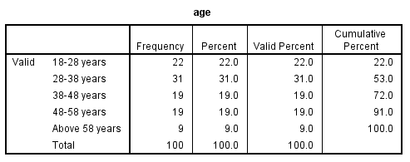
Table 2 Age Analysis
As evident from the above table, the respondents were mainly from the age group of 28-38 years and 18-28 years. The least number of participants were from above 58 years. This indicates that the youth and middle-aged people in the sample mainly use Vodafone. The graph of above information is below:
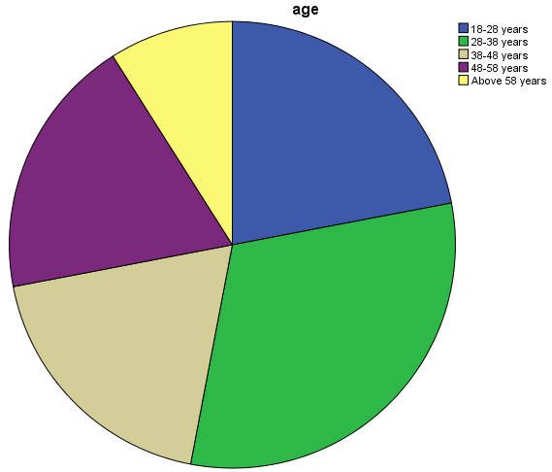
Figure 5 Age Analysis of Respondents
Gender Analysis
The gender of respondents were mainly categorised in male and female.
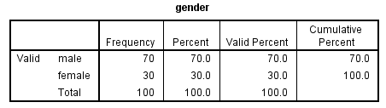
Table 3 Gender Analysis
However, it was seen that male participants were in large number comprising of 70% of the sample thus indicating a higher usage of Vodafone services by this gender within the selected sample population. The graph of above information is below:
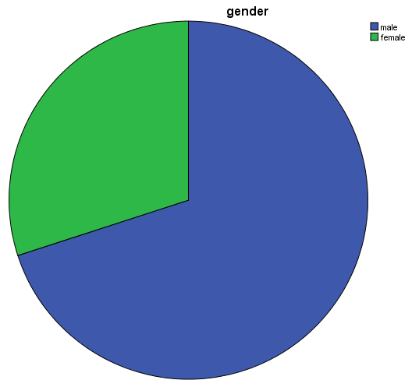
Figure 6 Gender Analysis
Occupation Analysis
The sample respondent belonged to differing walks of life ranging from students to home-makers and from employed (services / self-employed) to unemployed ones.
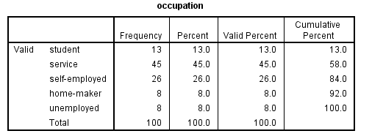
Table 4 Occupation Analysis
The above table highlights that the employed category was the dominant section that took part in this study. This segment comprised of both those having jobs (services) with 45% respondent and being employed by self with 26% respondent. This is an indicator of the fact that majority of the UK population especially those using Vodafone are employed and have a source of income. The graph of above information is below:
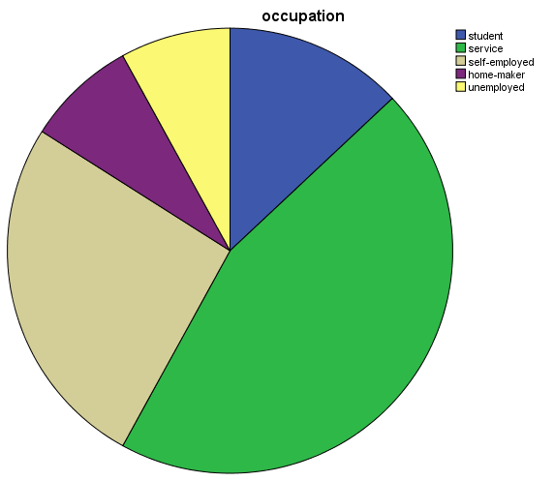
Figure 7 Occupation Analysis
Years of Association with Vodafone
This question was asked to understand the overall tenure of the relationship of consumers with Vodafone in the UK.
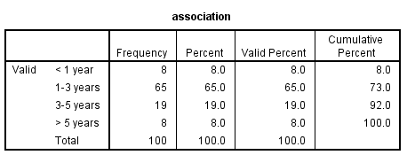
Table 5 Years of Association
The data collected highlights that the majority of the users that is 65% has been using Vodafone for more than 1 year but less than 3 years. Another major category is those who have been associated with Vodafone between 3 to 5 years with 19% of respondents belonging to this category. The graph of above information is below:
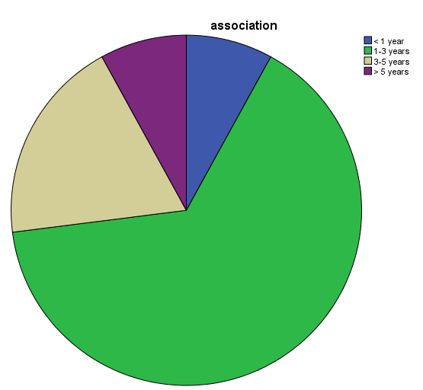
Figure 8 Years of Association
Type of Connection
The question aims at identifying the type of connection that is mainly used by consumers of Vodafone thus indicating the service category pre-dominantly demanded in the UK.
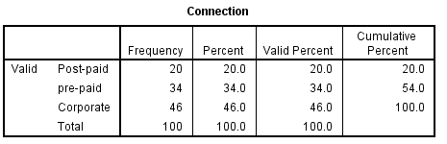
Table 6 Type of Vodafone Connection Prevalent in the UK
A majority of the sample respondents that is 46% were found to be using the corporate connection in the UK. This can be related to the fact that majority of the respondents were employed. Such connections are thereby generally provided by companies to their employees and in the case of self-employed to avail benefits of corporate services such connections are considered to be beneficial. Within the post-paid and pre-paid category, the latter was opted by majority of consumers that is 34% thus indicating its dominance over post-paid connections in the UK. The graph of above information is below:

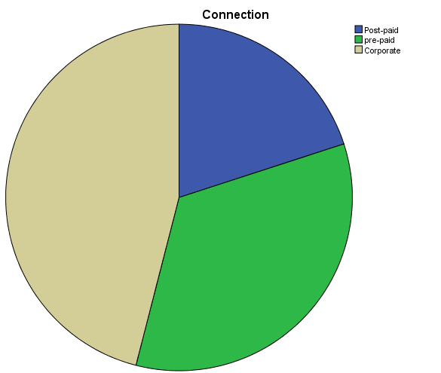
Figure 9 Type of Vodafone Connection Prevalent in the UK

4.2.3 Inferential Analysis
In this section, the correlation and regression analysis are undertaken to derive answers to the research questions formulated in the beginning of the study.

4.2.3.1 Research Question 1
- How effective is Vodafone’s relationship marketing approach in satisfying customers by meeting their requirements?
For understanding the satisfaction of consumers, it is first important to comprehend their acceptance levels towards the services provided by Vodafone in the UK. The analysis below is undertaken to understand the same and thus gauge consumer satisfaction levels.
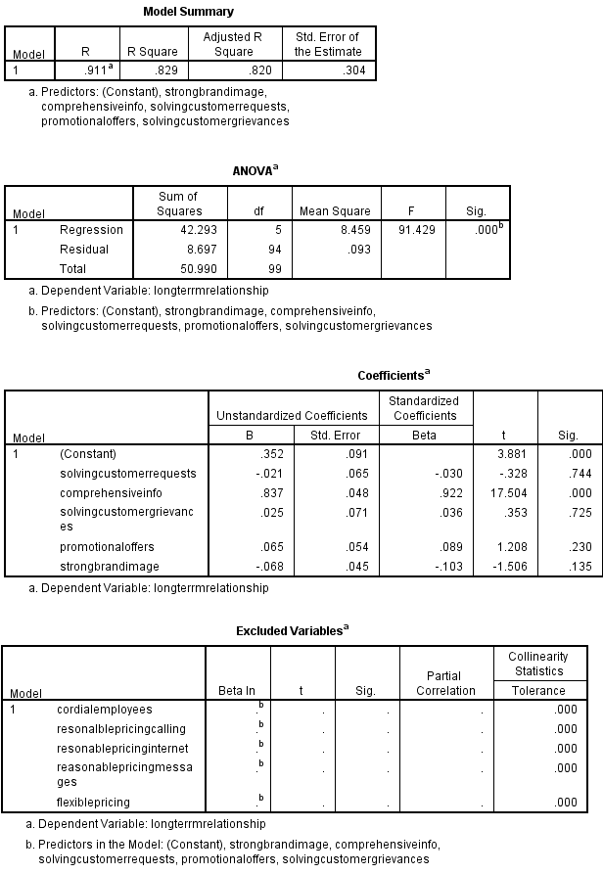
Table 7 Regression and ANOVA Analysis for Customer Acceptance of Vodafone Services

The independent variables that mainly have an influence on the consumer acceptance levels for services provided by Vodafone are mainly timely response to consumer queries, provision go comprehensive information, solution to consumer grievances, cordial employees in front-line and customer care, offers quality services for reasonable pricing for customers for calling, internet and messaging, flexible pricing approach depending upon services provided to customers, promotional offers to benefit customers and strong brand image. All these independent variables result in the development of a long-term relationship with the company. In this case, long-term relationship and customer acceptance levels are considered as a dependent variable as it they are to be measured. This long-term relationship is considered as a parameter of consumer satisfaction and thus chosen for analysis.
Regression analysis is shown in the Model Summary Table above. The R-square value outlines that the acceptance of consumers towards Vodafone services is proportionate to the long-term relationship parameter as there is a lower discrepancy of 0.829 indicating 82%. Further forecasting can be done easily based on this value owing to its proximity to 1. The next which is the ANOVA table highlights the value of F-tests. F test value is 91.42 when the p-value which is the significance level is .00. A higher value is thus a justification for the absence of discrepancy in the Model Summary Table. From the coefficient table, it can be determined that the long-term relationship between consumers and Vodafone is primarily affected by type and quality of services provided by the company. Thus, there exists a positive relationship between these two parameters. The t value is 17.50 and the value for p is .000 for comprehensive information provided to the consumers by the company at significance level 1. It is hence one of the most important factors behind customer acceptance of the company thus creating long-term relationships between the two. Another factor is solving consumer grievances which enhances consumer acceptance levels for Vodafone. In this case, t value is .353 and the value for p is .725. The third factor is the promotional offer as undertaken by the company from time to time to lure its customers. In accordance with the above table, t value is 1.208 and the value for p is .230
As seen in the Excluded Variables table, four independent variables namely, pricing of the calling services, pricing of internet services, pricing of messaging services and flexible pricing options to consumers are inconsistent with other data. These excluded from the analysis to overcome inconsistencies and capriciousness within the analysis which would have the case otherwise.

4.2.3.2 Research Question 2
- How to derive higher customer loyalty and customer commitment from relationship marketing in a competitive business environment?
Another parameter for understanding the satisfaction of consumers in determining the levels of customer commitment and customer loyalty towards Vodafone that fosters a long-term relationship with the company. The analysis below is undertaken to understand the same and thus identify the loopholes which will further help in the determination of measures that can be taken to enhance customer loyalty and commitment.

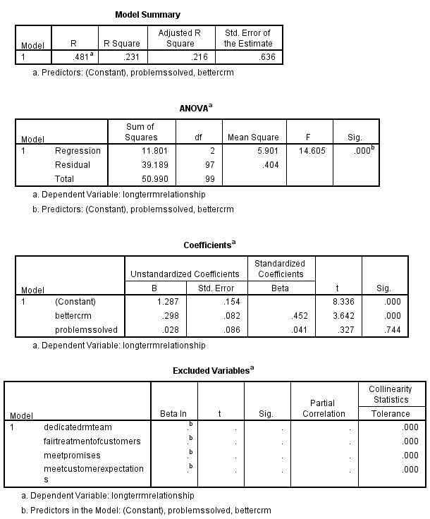
Table 8 Regression and ANOVA Analysis for Customer Commitment and Loyalty towards Vodafone Services
The independent variables that mainly have an influence on the consumer commitment and loyalty levels towards Vodafone are mainly dedicated team for relationship management with customers, fair treatment of customers by Vodafone through effective relationship management strategies, meeting promises made by the company, meeting customer expectations, solving problems of consumers without adversely affecting company's relationship with them and provision of better customer relationship management services. All these independent variables result in the development of a long-term relationship with the company. In this case, long-term relationship is considered as a dependent variable. This long-term relationship is considered as an outcome of consumer commitment and loyalty and thus chosen for analysis.
Regression analysis is shown in the Model Summary Table above. The R-square value outlines that the consumer commitment and loyalty towards Vodafone services are not completely proportionate to the long-term relationship parameter as there is a discrepancy of 0.23 indicating 23%. Further forecasting cannot be done easily based on this value owing to its lack of proximity to 1. The next which is the ANOVA table highlights the value of F-tests. F test value is 14.60 when the p-value which is the significance level is .00. A lower value is thus a justification of the presence of discrepancy in the Model Summary Table. From the coefficient table, it can be determined that the long-term relationship between consumers and Vodafone is primarily affected by the magnitude of problems solved by the company. Thus, there exists a positive relationship between these two parameters. The t value is .327 and the value for p is .744 for problems resolved by the company without having a negative impact on consumer relationship at significance level 1. It is hence one of the most important factors behind customer commitment and loyalty towards the company thus creating long-term relationships between the two. Also, it has been identified that Vodafone’s CRM approaches are better than the competitors as t value is 3.62 and the value for p is .000 for this parameter.
As seen in the Excluded Variables table, four independent variables namely, dedicated team for relationship management with customers, fair treatment of customers by Vodafone through effective relationship management strategies, meeting promises made by the company and meeting customer expectation are excluded from the analysis to overcome inconsistencies and capriciousness within the analysis which would have the case otherwise.

4.2.4 Consumer Satisfaction Levels and Suggestions
Satisfaction with Services
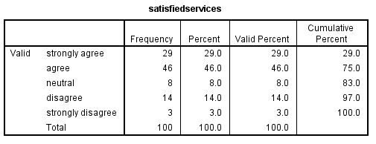
Table 9 Customer Satisfaction with Services offered by Vodafone
The sample respondents were found to be quite satisfied with the services provided by Vodafone with 75% respondents agreeing (46% agreed and 29% strongly agreed) to the same. 15% respondents (14% disagreed and 3% strongly disagreed) were not satisfied with the services of Vodafone and 8% were neutral. Thus, it can be determined that satisfaction with services by Vodafone amongst customers in relatively higher in the UK. The graph of above information is below:
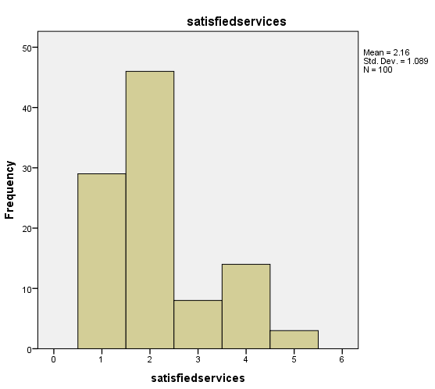
Figure 10 Customer Satisfaction with Services offered by Vodafone

Satisfaction with Prices
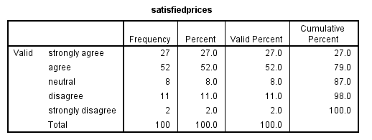
Table 10 Customer Satisfaction with Prices charged by Vodafone
The sample respondents were found to be quite satisfied with the prices charged by Vodafone with 79% respondents agreeing (52% agreed and 27% strongly agreed) to the same. 13% respondents (11% disagreed and 2% strongly disagreed) were not satisfied with the prices charged by Vodafone and 8% were neutral. Thus, it can be determined that satisfaction with price cost structure of Vodafone amongst customers in relatively higher in the UK. The graph of above information is below:

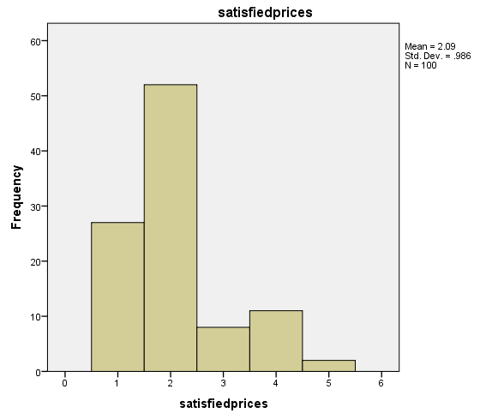
Figure 11 Customer Satisfaction with Prices charged by Vodafone

Recommendations
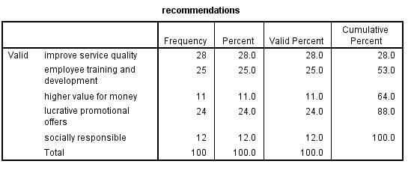
Table 11 Customer Recommendations to Improve Relationship Marketing by Vodafone
Most of the customers were of the opinion that it is important for Vodafone to further enrich its quality of services (28% respondents) and train their employees for the provision of better services (25%). The customers further expect the company to provide them with better promotional offers (24% respondents) to ensure they stay associated with Vodafone. It is also expected that company should provide for higher value for money (11% respondents) and also behave responsibly (12% respondents). The graph of above information is below:
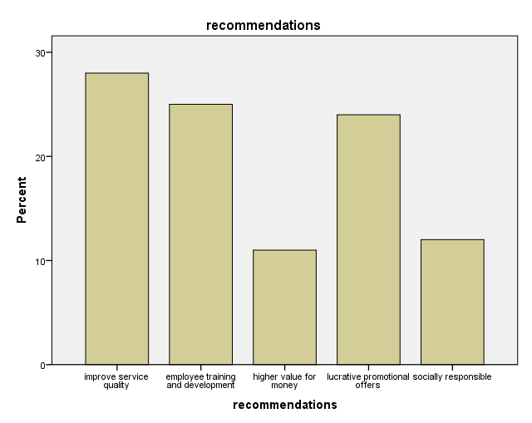
Figure 12 Customer Recommendations to Improve Relationship Marketing by Vodafone

4.3 Data Interpretations
In this sub-section, a brief answer to the research questions has been derived based on the analysis undertaken in the previous section. It has been observed that most of the company’s customers have corporate connections and have been associated with the company between the time frame of 1 to 3 years. Corporate connections are those which are provided to a group of people mainly a part of an enterprise or organisation with additional benefits that are not provided to other retail / individual customers. This is an indicator of the customer approval and acceptance of Vodafone’s relationship marketing approach.
Research Objective 1: How effective is Vodafone’s relationship marketing approach in satisfying customers by meeting their requirements?
The analysis highlights that there exists a positive relationship between relationship marketing approach by Vodafone in satisfying customers by meeting their requirements. It is this satisfaction level that motivates consumers to stay associated with the company for a longer period of time. Relationship marketing approaches like provision of comprehensive information to the customers thus gaining consumer confidence by having a transparent communication with them is one of the approaches that has supported Vodafone in meeting their needs and thus satisfying them. Other relationship marketing approaches considered to be important for the company are promotional offers undertaken by Vodafone from time to time and attempts made to resolve consumer grievances at the possible earliest in the most effective manner.
The analysis also highlights that pricing of different services and pricing policy of the company along with employee approach in customer care are not a major factor that affects customer relationship with Vodafone. Also, brand image of the company and its approaches to meet customer requests was found to be ineffective in satisfying customers and thus are considered to be unimportant as a part of company’s relationship management strategy.
Research Objective 2: How to derive higher customer loyalty and customer commitment from relationship marketing in a competitive business environment?
The analysis highlights that there exists a positive relationship between relationship marketing approach by Vodafone in enhancing customer loyalty and customer commitment by meeting their requirements in a competitive business environment. Amongst all the service providers in the UK, the CRM approaches adopted by Vodafone are superior and thus act as a major factor in enhancing consumer loyalty and commitment towards the company. Also, the approaches and attempts made by Vodafone to resolve consumer issues without hampering its relationship with them are considered to be a positive approach by the consumers. In this case, it was found that employees involved in relationship marketing are not considered to be effective in supporting the development of customer loyalty and customer commitment.

4.4 Chapter Conclusion
This chapter has been an opportunity to learn? as dedicated efforts were made to delineate answers for research questions in hand. The information procured has been enlightening as it throws light on customer perspective as well as the company’s approaches. The next chapter is the final chapter which highlights the findings from the study and puts forward concluding remarks along with recommendations.

Chapter 5 Findings, Conclusion and Recommendations

5.1 Chapter Introduction
The chapter is the concluding chapter in which the information gathered from both primary and secondary sources is summarised to meet the research objectives. Further based on the findings the recommendations are put forward and scope for further research is outlined.

5.2 Findings and Conclusion
The findings of the study can be understood by mapping them with the research objectives defined at the beginning of the study.
To review existing literature on relationship marketing with particular emphasis on telecommunication sector
The existing literature clearly highlights that relationship marketing in the telecommunication industry is very important as it is one of the significant factors affecting consumer satisfaction. It was further identified that consumer satisfaction levels determine the tenure of association the consumer wants to keep with the company. Thus, for companies seeking for long-term relationships they need to focus on relationship marketing.
To determine perceptions of customer care and relationship marketing approaches adopted within the telecommunication industry by Vodafone
Consumers have a positive perception with regards to customer care and relationship marketing approaches as adopted within telecommunications industry by Vodafone. It is evident from the analysis of primary data where consumers show higher levels of satisfaction for products and services offered by the company. Further, the consumers seek a long-term relationship with the company and are not affected by the pricing of the products/services.
To determine role of relationship marketing in creating customer commitment and loyalty towards Vodafone
Relationship marketing of Vodafone has played a dominant role in creating customer commitment and loyalty. It was found that most of its consumers in the UK were associated with the company for more than a year but less than 3 years which is considered to be a significant time frame considering that it is a competitive industry. Consumers are satisfied with the varied promotional offers of the company along with it approaches to solve consumer problems. The problems are resolved without hampering its relationship with the consumers which makes it evident that the company focuses on the sustained relationship with its consumers. Vodafone has also been accepted by the consumers for its better CRM which makes the company superior to others within the industry.
To identify ways in which effective relationship marketing practices are undertaken by Vodafone might be enhanced
Though the consumers are highly satisfied with Vodafone yet they have put forward certain approaches that the company needs to resort to for enhancing its relationship marketing practices. These are highlighted in the section of recommendations in this chapter.
To reflect on the implications of the analysis for the research on relationship marketing in telecommunications industry
Overall, it can be notified that relationship marketing is very important for the companies operating within the telecommunication industry. From the secondary data, it is clear that appropriate relationship marketing results in higher customer satisfaction which enhances their commitment and loyalty towards the company. The outcome is increased profitability and sales of the company. Further, it gives a competitive edge to the company to others within the industry through strong brand image and positive word of mouth communication. The primary data affirm these findings.

5.3 Recommendations
Based on the analysis and findings from the same, the following recommendations are put forward:
- Employee training and development: As telecommunication companies like Vodafone operate within the service industry, the role of employees is critically important. For ensuring quality and contemporary services to the consumers, the companies need to continually train and develop their employees especially on aspects of relationship management. These employees are mainly the front-end ones who have direct interactions with customers.
- Service Quality Improvement: In order to stay competitive and continue to maintain a long-term relationship with the customers, it is recommended that Vodafone should continue to focus on improving its service quality. This is possible through innovative approaches to using the faster internet and higher connectivity. It should have a differing department to deal with consumer complaints especially those related to internet and connectivity issues.
- Promotional Offers: Vodafone should continue to design and offer its customers new promotional plans thus exciting them and offering them value for money. Such promotional offers are important as they are highly demanded by consumers and makes it possible for the company to outshine its competitors.
- Socially Responsible: As the company operates within the society it needs to focus on social responsibilities especially towards the society. This will assist in reducing carbon footprint as well as minimise wastages. Through relationship marketing minimum wastages of resources like papers would be eliminated as the employees will be using personal approach for circulation of information. The marketing of corporate social responsibility will also help Vodafone lure its customers.

5.4 Future Scope of Research
Though an extensive study has been undertaken for Vodafone with regards to relationship management for its customers in the UK this study is limited in its scope. The study focuses on customers perspective with regards to relationship marketing and gauges their satisfaction levels. However, a study to analyse the organisational perspective also would have been enlightening. Further, the study focuses only on Vodafone which limits its scope. A comparative study of major players within telecom industry in the UK would have resulted in a more comprehensive understanding of the subject area that is relationship marketing. Also, there is scope to conduct a comparative study of nations with regards to Vodafone's relationship marketing approaches in differing markets thus gauging the satisfaction levels of differing customers hailing from differing nations. Also, a qualitative assessment for analysing Vodafone’s perspective can also be focused upon in future studies.

References
Abdullah, M., Putit, L. & Teo, C., 2014. Impact of Relationship Marketing Tactics (RMT's) & Relationship Quality on Customer Loyalty: A Study within the Malaysian Mobile Telecommunication Industry. Procedia - Social and Behavioral Sciences, Volume 130, pp. 371-378.
Adjei, M., Griffith, D. & Noble, S., 2009. When do relationships pay off for small retailers? Exploring targets and contexts to understand the value of relationship marketing. Journal of Retailing, Volume 85, pp. 493-501.
Agariya, A. & Singh, D., 2011. What Really Defines Relationship Marketing? A Review of Definitions and General and Sector-Specific Defining Constructs. Journal of Relationship Marketing, 10(4), pp. 203-237.
Akers, H., 2017. Advantages & Disadvantages of Customer Relationship Marketing. [Online]
Available at: http://smallbusiness.chron.com/advantages-disadvantages-customer-relationship-marketing-45503.html
[Accessed 28 Oct 2017].
Alibhai, A., 2015. Influence of Customer Relationship Marketing Strategies on Performance of Synthetic Hair Manufacturers in Kenya. IOSR Journal of Business and Management , 17(4), pp. 66-71.
Bailey, K., 2008. Methods of Social Research. 4 ed. New York: Simon and Schuster.
Bartolacci, M. & Powell, S., 2012. Research, Practice, and Educational Advancements in Telecommunications and Networking. Hershey: IGI Global.
Bazini, E., Elmazi, L. & Sinanaj, S., 2012. Importance of relationship marketing management in the insurance business in Albania. Procedia-Social and Behavioral Sciences, Volume 44, pp. 155-162..
Bejou, D. & Palmer, A., 2012. The Future of Relationship Marketing. Oxon: Routledge.
Benouakrim, H. & Kandoussi, F., 2013. Relationship Marketing: Literature Review. International Journal of Science and Research, 2(10), pp. 148-152.
Brace, I., 2008. Questionnaire Design: How to Plan, Structure and Write Survey Material for Effective Market Research. London: Kogan Page Publishers.
Bradley, C., 2013. Handbook of Psychology and Diabetes: A Guide to Psychological Measurement in Diabetes Research and Practice. Oxon: Routledge.
Brown, J. & Coombe, C., 2015. The Cambridge Guide to Research in Language Teaching and Learning. Cambridge: Cambridge University Press..
Channel Reply, 2015. The Top 5 Benefits of Relationship Marketing. [Online]
Available at: https://www.channelreply.com/blog/view/benefits-of-relationship-marketing
[Accessed 28 Oct 2017].
Chapman, B., 2016. Vodafone fined £4.6m by Ofcom for ‘serious and sustained’ customer failings. [Online]
Available at: http://www.independent.co.uk/news/business/news/ofcom-fines-vodafone-46m-for-customer-failings-a7380471.html
[Accessed 3 Nov 2017].
Cheng, C. & Lee, A., 2011. The influences of relationship marketing strategy and transaction cost on customer satisfaction, perceived risk, and customer loyalty. African Journal of Business Management , 5(13), pp. 5199-5209.
Creswell, J., 2014. Quantitative research design. 4 ed. London: Sage Publications.
Egan, J., 2011. Relationship Marketing: Exploring relational strategies in marketing. 4 ed. Essex : Pearson Education Limited.
Emmanuel, N., Aham, A. & Cosmas, N., 2016. Effect of Relationship Marketing Strategies on Consumer Loyalty: A Study of Mobile Telephone Network (MTN) Nigeria. International Journal of Management and Commerce Innovations, 3(2), pp. 798-810.
Euromonitor International, 2016. Telecommunications in United Kingdom: ISIC 642. [Online]
Available at: http://www.euromonitor.com/telecommunications-in-united-kingdom-isic-642/report
[Accessed 5 Nov 2017].
Fox, W. & Bayat, M., 2008. A Guide to Managing Research. Cape Town: Juta and Company Ltd..
GlobalData, 2015. Vodafone Group PLC (VOD) - Financial and Strategic SWOT Analysis Review, London: Research and Markets.
Hollensen, S. & Opresnik, M., 2010. Marketing: A Relationship Perspective. München: Verlag Franz Vahlen .
Ibok, N. & Sampson, E., 2014. Factors Affecting the Effectiveness of Relationship Marketing in the Nigerian Telecommunication Industry: The Customers Perspective. International Journal of Managerial Studies and Research, 2(10), pp. 94-101.
King, T., 2017. Advantages & Disadvantages of Customer Relationship Marketing. [Online]
Available at: http://yourbusiness.azcentral.com/advantages-disadvantages-customer-relationship-marketing-13637.html
[Accessed 28 Oct 2017].
Koi-Akrofi, G., Koi-Akrofi, J. & Welbeck, J., 2013. Relationship Marketing Tactics and Customer Loyalty-A Case of the Mobile Telecommunication Industry in Ghana. Asian Journal of Business Management, 5(1), pp. 77-92.
Korrapati, R., 2016. Five Chapter Model for Research Thesis Writing: 108 Practical Lessons for MS/MBA/M.Tech/M.Phil/LLM/Ph.D Students. New Delhi: Diamond Pocket Books Pvt Ltd.
Lacey, R., Suh, J. & Morgan, R., 2007. Differential effects of preferential treatment levels on relational outcomes. Journal of Service Research, 9(3), pp. 241-256..
Lalaounis, S., 2017. Design Management: Organisation and Marketing Perspectives. Oxon: Routledge.
Lancaster, H., 2017. United Kingdom - Telecoms Infrastructure, Operators, Regulations - Statistics and Analyses, London: Paul Budde Communication Pty Ltd.
Lo, A. & Stalcup, L., 2010. Customer relationship management for hotels in Hong Kong. International Journal of Contemporary Hospitality Management, Volume 22, pp. 139-159..
McMullan, R. & Gilmore, A., 2008. Customer loyalty: an empirical study. European Journal of Marketing, 42(9/10), pp. 1084-1094.
Moretti, A. & Tuan, A., 2013. Social Media Marketing and Relationship Marketing: revolution or evolution? A first step analysis. Ancona, Università Politecnica delle Marche.
Ofcom, 2016. The Communications Market 2016, London: Ofcom.
Ojo, O., 2010. The Relationship Between Service Quality and Customer Satisfaction in the Telecommunication Industry: Evidence From Nigeria. BRAND. Broad Research in Accounting, Negotiation, and Distribution , 1(1), pp. 88-100.
Paliwal, R. & Indu, 2013. The Role of Consumer Happiness in Relationship Marketing. Global Journal of Management and Business Studies. , 3(4), pp. 407-412 .
Palmatier, R., 2008. Relationship Marketing. Cambridge: Marketing Science Institute.
Palmatier, R., Jarvis, C., Bechkoff, J. & Kardes, F., 2009. The Role of Customer Gratitude in Relationship Marketing. Journal of Marketing, Volume 73, p. 1–18.
PwC, 2016. Telecommunications providers should plan for Brexit. [Online]
Available at: https://www.pwc.com/us/en/brexit-us/telecom.html
[Accessed 3 Nov 2017].
Raza, A. & Rehman, Z., 2012. Impact of relationship marketing tactics on relationship quality and customer loyalty: A case study of telecom sector of Pakistan. African Journal of Business Management , 6(14), pp. 5085-5092.
Rizan, M., Warokka, A. & Listyawati, D., 2014. Relationship Marketing and Customer Loyalty: Do Customer Satisfaction and Customer Trust Really Serve as Intervening Variables?.. Journal of Marketing Research & Case Studies, 2014(2014), pp. 1-12.
Saris, W. & Gallhofer, I., 2014. Design, Evaluation, and Analysis of Questionnaires for Survey Research. 2 ed. New Jersey: John Wiley & Sons..
Saunders, M., Lewis, P. & Thornhill, A., 2009. Research Methods for Business Students. 5 ed. Essex: Pearson Education.
Sonková, T. & Grabowska, M., 2015. Customer engagement: transactional vs. relationship marketing. Journal of International Studies, 8(1), pp. 196-207.
Statista, 2017. Market share held by mobile operators in the United Kingdom (UK) as of June 2015. [Online]
Available at: https://www.statista.com/statistics/375986/market-share-held-by-mobile-phone-operators-united-kingdom-uk/
[Accessed 9 Nov 2017].
Taleghani, M., Gilaninia, S. & Mousavian, S., 2011. The Role of Relationship Marketing in Customer Orientation Process in the Banking Industry with focus on Loyalty (Case Study: Banking Industry of Iran). International Journal of Business and Social Science , 2(19), pp. 155-166.
Tauni, S., Khan, R., Durrani, M. & Aslam, S., 2014. Impact of Customer Relationship Management on Customer Retention in the Telecom Industry of Pakistan. Industrial Engineering Letters , 4(10), pp. 54-59.
Vodafone Plc, 2015. Unifying Communications: Annual Report 2015, London: Vodafone Plc.

Annexure

Annexure 1: Questionnaire Cover Letter
Date
Dear Participant

Myself …………………………………………. is a MBA student at ……………………………………… University. As a part of my curriculum I am preparing a business project in which I aim to analyse significance of relationship marketing approaches in the UK’s telecom sector with Vodafone as the case company. For this a survey is to be undertaken of the Vodafone consumers and thus I would request you to cordially participate in the survey and provide your opinion without any compensatory expectations. I would like to assure you that the information provided by you will be completely confidential and the participation will be free from any kind of risks as anticipated in present environment. Once the project has been completed the same will be submitted to the University and my instruction without revealing the details of the participants. In the case where you need a copy of this study a summarised report will be sent to you. This questionnaire will help in conducting my research in real terms and thus seeking for your kind cooperation. You are free to put forward your suggestions, requirements or complaints if any to the contact details (instructor or me) notified below.
Looking for a positive response.
Sincerely,

(Student Name)
(Student Phone number)
(Student email id)

(Instructor name)
(Instructor Phone number)
(Instructor email id)

Annexure 2: Quantitative Questionnaire for Consumers
Section A : Demographic Profile
Age:
- 18-28 years
- 28-38 years
- 38- 48years
- 48-58 years
- 58 years and above
Gender:
- Male
- Female
Occupation:
- Student
- Service
- Self- Employed
- Home-Maker
- Unemployed
Years of Association with Vodafone
- < 1 year
- 1-3 years
- 3-5 years
- > 5 years
Type of Connection
- Post-paid (individual)
- Prepaid (individual)
- Corporate (post-paid / pre-paid)
Section B: Relationship Marketing and Customers
- Customer Acceptance of Customer Relationship Marketing undertaken by Vodafone (UK) by rating on a scale of 1-5 where 1= strongly agree, 2= agree, 3= neutral, 4= disagree, and 5= strongly disagree
Statement | 1 | 2 | 3 | 4 | 5
Vodafone resolves customer requests in a timely manner
Vodafone has cordial employees in front-line and customer care
Vodafone provides comprehensive information to its customers
Vodafone resolves consumer grievances thereby ensuring customer satisfaction
Vodafone offers quality services for reasonable pricing for customers for calling
messaging)
Vodafone offers quality services for reasonable pricing for customers for internet
Vodafone offers quality services for reasonable pricing for customers for messaging)
Vodafone resorts to flexible pricing approach depending upon services provided to customers
Vodafone makes promotional offers that are beneficial for the customer
Vodafone has a strong brand image

- Customer Commitment, Customer Loyalty and Relationship Marketing by Vodafone (UK) (rate on a scale of 1-5 where 1= strongly agree, 2= agree, 3= neutral, 4= disagree, and 5= strongly disagree)
Statement | 1 | 2 | 3 | 4 | 5
Vodafone has a dedicated team for relationship management with customers
Vodafone treats its customers fairly through effective relationship management strategies
Promises made by Vodafone are duly honoured by the company
Vodafone ensures that it meets customer expectations
Vodafone offer a better customer relationship than competitor firms
Problems are resolved by the company without negatively affecting customer relationship

Section C: Concluding Views
- Satisfaction Reviews about Vodafone on the scale of 1-5 where 1= strongly agree, 2= agree, 3= neutral, 4= disagree, and 5= strongly disagree
Statement | 1 | 2 | 3 | 4 | 5
I am satisfied with the company and its services
I am satisfied with the prices and promotional offers availed by me
I will stay with the company for the foreseeable future

- What suggestions would you like to give to Vodafone for further enhancing its approach to
- Improve service quality
- Training and development of employees for undertaking effective relationships
- Providing higher value of money
- Making lucrative promotional offers
- Behaving with greater social responsibility
- Others (please specify) ....................................................................
Any Other Comments ________________________________________________________________________________________________________________________________________________________________________________________________________________________________________________________
Thank you for your time!!

Annexure 3: Reflective Statement

This course in particular has been very enlightening for me as I was exposed to differing kinds of learnings. This not only enriched my knowledge but also assisted in gaining novel skills which would have not been possible otherwise. I feel that the overall course and this research in particular has been a great source of information and developed my acquaintance in spheres of business management especially planning, management, marketing and relationship marketing.
After expansive analysis of differing topics that I could have researched upon along with discussions with family, colleagues, friends, faculty members and self I settled upon conducting a research in the area of relationship marketing as it created a sense of excitement in me. Though a series of formal sessions were undertaken in the class for undertaking the research I was not very sure about the same owing to my limited expertise and skills required for the same. Thus, making this research report was itself challenging for me.
The area of research chosen that is relationship marketing is itself a very broad area of research and thus it was important to narrow it down for making research easy yet effective. Hence, upon further study of information from secondary sources the topic that is “Importance of Relationship Marketing Management in a Competitive Environment - An Analysis of Vodafone in UK” was chosen to ensure that precise information can be collected and thus a focused research would be executed.
With my limited experience I started with my research and first formulated the research objectives. After multiple revisions by self I got them approved from my instructor and thus moved ahead with my study. The most difficult task was collection of information both primary and secondary. Secondary information was an issue mainly because data filtration was required to chose specific information from a pool of data that was available. For primary data collection, approaching the sample respondents was challenging as I am not very good in face-to-face communications. To overcome this problem, I took the help of technology and conducted an online survey.
A good research is an outcome of knowledge synthesis, knowledge analysis and knowledge application. This process was subjected to a number of issues but yet I was able to overcome the same and achieve my research objectives. I was able to develop skills which I lacked as identified above.

